**PATHFINDER ELEMENT FOOTPRINTS OF EASTERN AUSTRALIAN MINERAL DEPOSITS**

**Scott Halley,**

Mineral Mapping Pty Ltd

**INTRODUCTION**

Pathfinder elements increase the detectable footprints of mineral deposits because they have a wider spatial distribution than the commodity metals being sought. The most useful elements are those that are hosted in common alteration minerals such as pyrite, white mica or chlorite. Since those minerals have a wide distribution, every sample within the anomalous footprint of a particular element returns an anomalous value, ie every sample is likely to contain pyrite or muscovite or chlorite, thus give an anomalous result for the pathfinders contained in that mineral. That increases the likelihood that any one sample will be representative of a larger volume of rock, and it reduces the number of samples needed in order to detect the footprint of a hydrothermal system.

Porphyry Cu deposits, for example, have the same metal zoning patterns and relative abundance of elements regardless of their geographic location. This indicates the patterns are controlled by the same chemical and physical processes, more so that local factors.

**PORPHYRY COPPER PATHFINDERS**

In the outflow zone above and laterally from porphyry centers there is a metal zoning; Mo - Se - Sn - Te - Bi - As - Sb. Sn occurs in the most proximal white mica. Mo, Se, Te, Bi, As, Sb are hosted in pyrite and are accommodated sequentially in the pyrite lattice as temperature declines (Halley et al., 2015). The pathfinder element zoning pattern around a porphyry system is a proxy for temperature, regardless of whether the pyrite is associated with phyllic or advanced argillic alteration. In acid alteration zones, ie phyllic and advanced argillic, where Fe-Mg silicates are replaced, Mn and Zn in particular are stripped from the rock. These metals tend to be enriched on the margins of the acid alteration where there is enough relict feldspar to neutralise the acid. Mn is enriched in chlorite and/or carbonates and Zn is enriched in chlorite and/or sulfides in propylitic alteration on the margins of the phyllic zones.

**LOW SULFIDATION EPITHERMAL PATHFINDERS**

Epithermal systems are dominated by low temperature fluids. In active geothermal systems, antimony values above 2ppm and cesium above 10ppm are mostly limited to within 1km of the surface, and are precipitated at temperatures less than 200 degrees (Chambefort and Dilles, 2023). In the near surface environment, it is common to see lateral fluid flow producing extensive clay blankets. Sb is a proxy for low temperature pyrite. Cs, Li and W are proxies for low temperature phyllosilicates. In LSE systems eroded to deeper levels, it is common to see anomalous Mo-Bi-Te zones that are likely fed by upwelling magmatic fluids. At a prospect scale, the association of elements should make it possible to determine the level within the system, and the outflow from blind LSE ore shoots should be evident (Thompson et al., 2023).

**VMS PATHFINDERS**

In VMS systems, hydrothermal fluids quench directly into cold seawater. A characteristic of this is pyrite containing high levels of thallium. Pyrite in the massive sulfide and in the footwall quartz-sericite-pyrite +/- chlorite alteration contains high levels of As-Sb-Tl. Systems that have a direct magmatic contribution also have high levels of Bi and Te deeper in the stringer zones. In the acid footwall alteration zones there is a measurable depletion in zinc and manganese especially. Where the host sequence has been sufficiently tilted but not dissected by faulting, the depletion zones might be traceable back to an underlying granite pluton (Brauhart et.al, 2001).

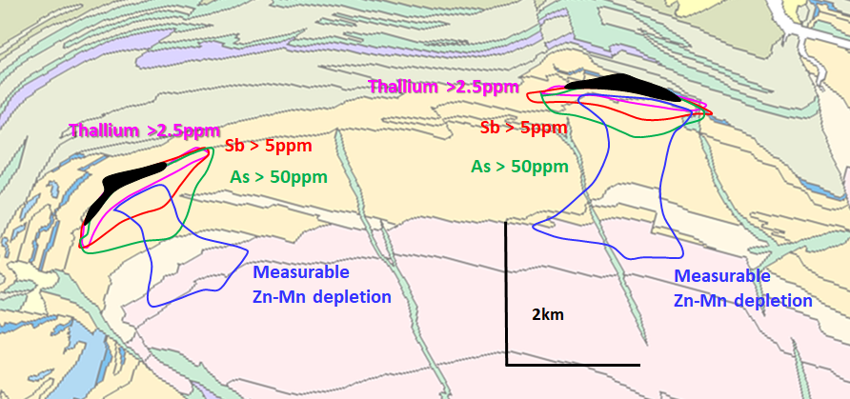

**SAMPLING STRATEGIES**

ICP-MS analysis is required to achieve suitable detection limits for elements such as Sb, Bi, Te, Se, Sn and W. A 4-acid digestion is required to liberate elements contained within silicate minerals and refractory oxide phases. Sampling in-situ bedrock material is strongly preferred rather than partial leach or ultra-fine fraction methods in transported overburden, ie a pattern of aircore drilling to obtain bedrock samples. For any system of a substantial size, a sampling pattern of 400m by 400m should be sufficient. This pattern is certainly adequate in first-pass exploration of porphyry Cu deposits. The big advantage of using pathfinder signatures in deeply weathered regolith profiles is that elements such as Mo, Bi, Te, As, Sb etc form oxy-anion complexes which are relatively immobile in the regolith, even where Cu, Zn, Au and Ag are strongly leached and depleted.

**REFERENCES**

BRAUHART, C.W., HUSTON, D.L., GROVES, D.I., MIKUCKI, E.J. AND GARDOLL, S.J., 2001. Geochemical mass-transfer patterns as indicators of the architecture of a complete volcanic-hosted massive sulfide hydrothermal alteration system, Panorama district, Pilbara, Western Australia. Economic Geology, 96(5), pp.1263-1278.

CHAMBEFORT, I. AND DILLES, J.H., 2023. Chemical vectoring in continental geothermal systems: Composition of altered rocks and illite as guides to magmatic degassing. Geothermics, 110, p.102682.

HALLEY, S., DILLES, J.H. AND TOSDAL, R.M., 2015. Footprints: Hydrothermal alteration and geochemical dispersion around porphyry copper deposits. SEG newsletter, (100), pp.1-17.

THOMSON, B., PRATT, W.T., RHYS, D.A., OLIVER, N.H., HALLEY, S.W., FISCHL, P., AKININ, V.V. AND DOTZOV, D., 2023. The Kupol Epithermal Au-Ag Vein District, Chukotka, Far Eastern Russia. Economic Geology, 118(1), pp.93-122.